4.1: Function of the Nucleus within the Cell Name:

Objectives: By the end of the lesson you should be able to:
________________________________________________________________________________________________________________________________________________________________________________________________________________________________________________________________________________________________________________________________________________________________________________________________________________

Recall:
The Cell Theory States:

- ________________________________________________________________________
- _________________________________________________________________________
- _________________________________________________________________________

Parts of the Cell:
- Draw a rough sketch of both a plant and animal cell below. Label all the parts you can.

Plant Animal

The Nucleus:

- The nucleus contains the master set of ________________________ that determine what the cell will ____________________, how it will function, and when it will _________________, ________________________, and when it will ________________.

Now it is your turn! Complete the chart of the organelles of the cell and label the diagrams of the cells, nucleus, and DNA strand.

The Nucleus: Control Centre of the Cell

Objectives: By the end of the lesson you should be able to:
________________________________________________________________________________________________________________________________________________________________________________________________________________________________________________________________________________________________________________________________________________________________________________________________________________

Draw a rough sketch of a cell’s nucleus below. Label all the parts you can.

- Nuclear membrane – like the cell membrane _______________contents of the nucleus
- Nuclear pore- _____________ in the membrane that allow only __________ things in and out of the nucleus
- Nucleoplasm- _________ inside the nucleus
- Nucleolus- makes ____________________
- DNA- base pairs connected to form a double helix
- Chromatin- contains __________ and _________________
- Chromosome- coiled ________________ forms an “___” shape

DNA and Chromosomes

- DNA: the blueprint of ________________!
- Located in the nucleus in 46 “chunks” called _____________________________
- Each chromosome has sections that __________ for a specific _____________________
- These sections are called ___________________
- ________________is found inside the _______________ of animal and plant cells
- ________________________ during the cycle of ________________, take the form of chromatin. Chromatin (uncoiled) _________________ (shortens and thickens) during cell division to form the ____________________________.
- Chromatin is the substance that contains the _________ and the _______________. Within each strand of chromatin is one ______________________ of DNA.
Human DNA and DNA Structure
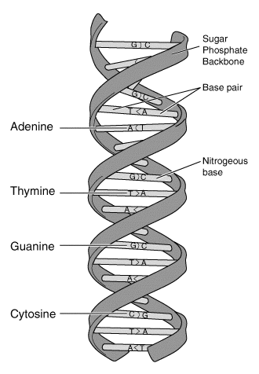
- Humans have _______ chromosomes
- That is: ______ pairs of chromosomes
- 23 from __________ and 23 from ______________
- Double _______________
- Sugar-phosphate _______________________
- _____ nitrogenous bases
- Complementary base pairing
  - A goes with ___; G goes with ____

- DNA is made of 4 bases: _______________, _______________, _______________, and _______________
- The sequence of the bases codes for a specific _______________________.

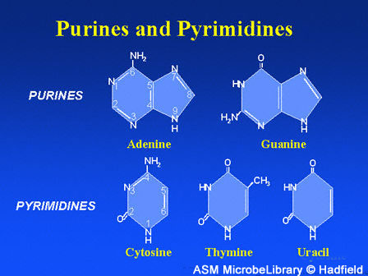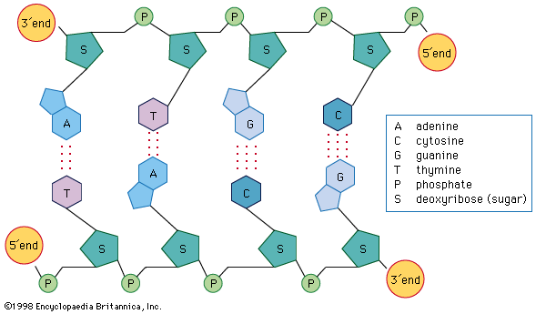

Making RNA

- Remember that RNA is just a __________________ of a section (gene) of DNA
- To make the RNA the DNA has to split (___________) down the middle so the RNA can read the bases and make the copy

Reading DNA

- When a photocopy of a gene is taken (RNA!) the DNA has to split so a copy can be made
- If you had to make a copy of a gene could you?? YES!!!
- Lets practice!

Mutations:
- If there is a ____________________________________of the DNA bases the amino acids will be different (and so will the proteins – thus, they may not be ______________________!!)

4 Types of Mutations:
1. _____________________________
2. _____________________________
3. _____________________________
4. _____________________________

Point Mutations:
- Change occurs at some point in the DNA sequence
  - ___________________________________________________________________
  - ___________________________________________________________________
- Effects range from _________________ to ___________________ depending on the ______
- EX: ____________________________________ (an A was replaced with a T in one location)

Chromosomal Mutations:
- Mutation in an ________________chromosome – present at conception
- Many genes affected (______________)
- Effects range from ______________________________ (almost always an effect)
- EX. ___________________________ – an extra X chromosome

Body Cell Mutation:
- Mutations of the body cells
- These are ____________________________
- Effects range from nothing to lethal
- EX.__________________

Sex Cell Mutations:
- Mutations in the sex cells
- These mutations ____________________________________
- These do not affect the person with the sex cells but can severely affect their ______________
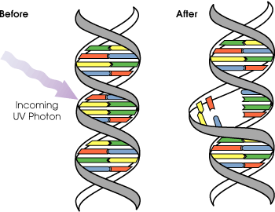
- EX. __________________________________!

Mutagens = ___________________________________
1. ______________: they simply happen randomly

2. ______________ : knocks holes in DNA
- __________ = sunlight skin cancer
- __________ = dentists and hospitals
- __________ = radiation for cancer
- ___________________ = none in BC

3. _______________: - ____________ = Illegal (PCP, LSD, Heroin, Cocaine)
= Legal (thalidomide)
- ____________ = formaldehyde, benzene, acetone, carbon tetrachloride

Effects of Mutations:
- ________________: organism benefits from the mutation
  - ______________________________________________________________________

- ________________: organism is harmed by the mutation
  - ______________________________________________________________________

- _______________: organism is not harmed or helped by the mutation
  - ______________________________________________________________________

Correcting Mutations:
- Normally through _________________________________________
- New technique = ___________________________
  - Replace a mutated gene with a healthy one
  - NOT EASY!!!

Gene Therapy:
- Inactive ________________ is inserted with healthy _______________
- Virus is shot (very difficult) into the _______________ of millions of target ________ (unhealthy gene)
- Patient must be able to “_______________” the healthy gene
  - Requires healthy gene to become attached to ____________________________
  - Healthy gene must be _____________ correctly
  - Healthy protein must be made – in the correct __________________

Let’s Talk!
- Activity 4-2B pg 143
- Bioengineered Bananas??
- Pg. 145 even numbered questions

