3.1 Compounds
Name: ________________
1. Name two ways in which elements can combine into compounds. What is the difference between them?
_______________________________________________________________________________________________________________________________________________________________________________________________________________________________________________________________
2. What needs to happen to atoms of different elements to allow them to combine to form an ionic compound?
_____________________________________________________________________________________
3. Use the diagram of the phosphate ion shown below to answer the following questions
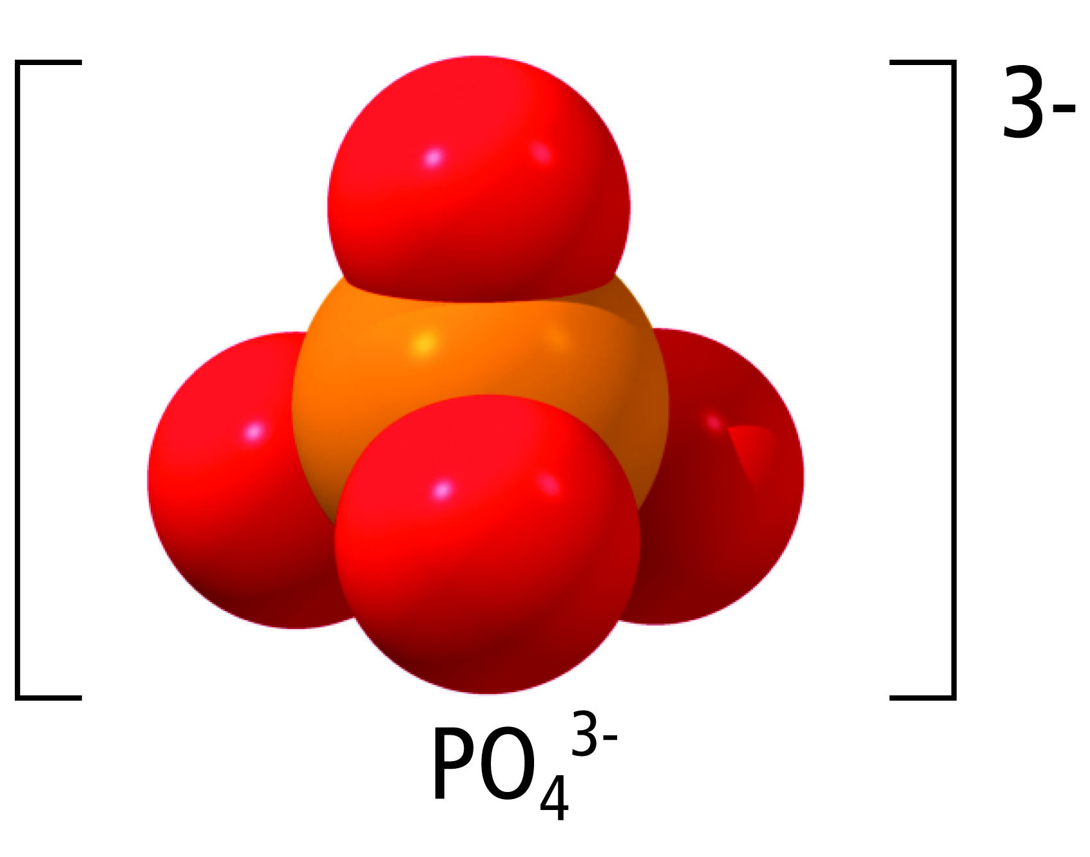
- What kind of chemical bond holds each oxygen atom to the phosphorus atom?
______________________________________________________________________________
- How many atoms does the phosphorus atom connect to?
______________________________________________________________________________
- What is the general term for an ion such as phosphate?
______________________________________________________________________________

4. Draw a beryllium and oxygen atom. Draw arrows to show where the electrons would move.

What kind of bond is this? _______________________________________________________________
5. Draw a 2 Sodium atoms and 1 Sulfur atom. Draw arrows to show where the electrons would move.

What kind of bond is this? _______________________________________________________________
6. Draw 1 Carbon atom and 2 oxygen atoms. Remember all 3 atoms want a full valence shell

What kind of bond is this? _______________________________________________________________

