|  |
| --- |
| Safety in the Science Classroom |

Name: Block: _______

What to do…

1. Read the 20 lab safety rules provided, then classify the safety rules by using the following category codes:
   * **F** for safety rules about ***fire***
   * **B** for safety rules about ***behaviour***
   * **C** for safety rules about ***chemicals***
   * **O** for other safety rules
2. After you have categorized the safety rules, **choose 10 rules** you believe to be **the most important**. Assign a priority number 1 to the most important, 2 to the next important and so on, up to 10. Place these numbers in the table.

| **Safety Rule** | **Category code**  **(F, B, C, or O)** | **Priority number**  **(1 to 10)** |
| --- | --- | --- |
| 1 - Always wear safety goggles whenever you are working with chemicals or other substances that might get into your eyes. |  |  |
| 2 - Never reach across a flame. |  |  |
| 3 - Immediately notify your teacher if any chemicals gets on your skin or clothing to find out what to do to clean it off. |  |  |
| 4 - Never look directly into a test tube when mixing or heating chemicals. |  |  |
| 5 - Always point a test tube away from you and others when heating it over a flame or other heat sources. |  |  |
| 6 - Never smell a chemical directly from the container. Wave your hand over the opening of the container and “waft” the fumes towards your nose. |  |  |
| 7 - Never taste a chemical unless you are instructed by your teacher to do so. |  |  |
| 8 - Always clean up your work area and equipment after an experiment is completed. Equipment must be returned to its proper place. |  |  |
| 9 - Read and follow all directions exactly as they are written. If in doubt, ask your teacher for help! |  |  |
| 10 - Never mix chemicals (or perform tests) without your teacher’s permission. |  |  |
| 11 - Never eat, drink, or chew gum in the science classroom. |  |  |
| 12 - Never run (or push someone else) in the lab. (I let the kids know this rule applies at all times!) |  |  |
| 13 – If any part of your body comes in contact with a chemical, wash the area immediately and thoroughly with water. Use eye wash station if it gets into your eyes. |  |  |
| 14 – If there is a fire, immediately get a fire extinguisher to put it out. |  |  |
| 15 - Never use broken or chipped glassware. If glassware breaks, inform your teacher and sweep up the broken glass. This is to be put into a broken glass (shard) container. |  |  |
| 16 - Keep your work area clean and keep all materials (clothing, hair, papers, etc.) away from a flame or heat source. |  |  |
| 17 – Never pour anything into a sink without your teacher’s permission. |  |  |
| 18 - Immediately notify your teacher if you get cut or have another injury when performing an experiment. |  |  |
| 19 - Wash your hands before and after each experiment. |  |  |
| 20 – If someone is on fire, tell them to “Stop, Drop, and Roll” and get the fire blanket to put on the as soon as possible. |  |  |

1. Consider Rules #9 and #10. In a paragraph, describe why these rules are so important.
2. Lab safety features in **Room 133** – look around the room and locate the following safety features/equipment. State where they are found and how many are in the classroom.

|  |  |  |
| --- | --- | --- |
| **Safety Feature/Equipment** | **Location** | **Number of Items** |
| Fire Blanket |  |  |
| Fume Hood |  |  |
| Exits |  |  |
| Sprinklers |  |  |
| Eye wash station |  |  |
| Fire Extinguisher |  |  |
| Sinks |  |  |

1. Consider the following terms:

* A ***safety procedure*** is a step-by-step description to guide scientists in a science classroom or if an accident occurs, how to handle the situation.
* A ***safety feature*** is an item found in a science classroom that is helpful in case of an emergency.
* A **safety hazard** is any source of potential damage, harm, or adverse health effects on someone in the science classroom.

Give one **example** of each of these terms in the table below.

|  |  |  |
| --- | --- | --- |
| **Safety Procedure** | **Safety Feature (Rm 133)** | **Safety Hazard (Rm 133)** |

1. List the steps you would take to deal with each of the following situations:

a) You are pouring hydrochloric acid into a beaker when someone accidently bumps into you. The hydrochloric acid splashes up and gets under your safety goggles.

b) While you are using an open flame, the shirt of someone near you catches fire.

c) You have a glass beaker at your work station. You accidently know the beaker onto the floor and it breaks.

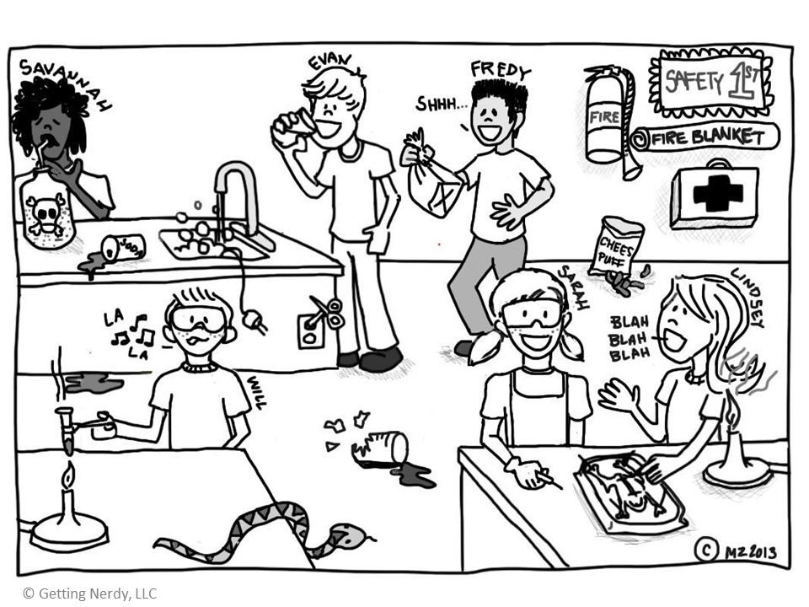

1. Describe **five** unsafe activities from the cartoon above. Include the name(s) of the individuals involved.

|  |  |
| --- | --- |
| **Name(s)** | **Unsafe Activity** |
|  |  |
|  |  |
|  |  |
|  |  |
|  |  |

1. Describe **three** safe activities from the cartoon above. Include the name(s) of the individuals involved.

|  |  |
| --- | --- |
| **Name(s)** | **Safe Activity** |
|  |  |
|  |  |
|  |  |

1. What does WHMIS stand for?
2. Name each of the following WHMIS symbols.

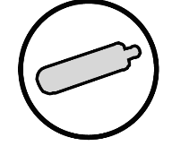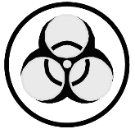

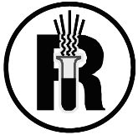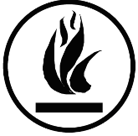

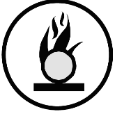

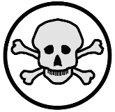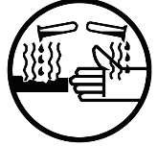

1. Why were Hazardous Household Product Symbols (HHPS) developed?

1. Label each of the Hazard Symbols found below, give a brief explanation of each, and state where you may have seen this symbol in your daily life.

|  |  |  |  |  |
| --- | --- | --- | --- | --- |
| **Hazard Symbol** |  |  |  |  |
| **Brief Explanation** |  |  |  |  |
| **Seen in Daily Life** |  |  |  |  |

**Bringing It All Together**

1. List 5 things you need to know before you start a science activity:

* _
* _
* _
* _
* _

1. Explain the difference between knowledge of safety procedures and awareness of safety hazards.
2. Why should we learn about safety skills and practices?